Pulse BioScience Documentation

7/20/2017

A. Inventory Manager  - Creating of New Assembly Items.

B. Controller - New Standard Cost Version Creation

C. Controller -  Item Costing & Roll Up

    C.1. Controller -  Item Costing

    C.2. Controller -  Item RollUp

D. Controller - Fixed Assets module

**A. Inventory Manager - Creating New Items**

1. New Item Creation ( Inventory > Lists > Items > New)

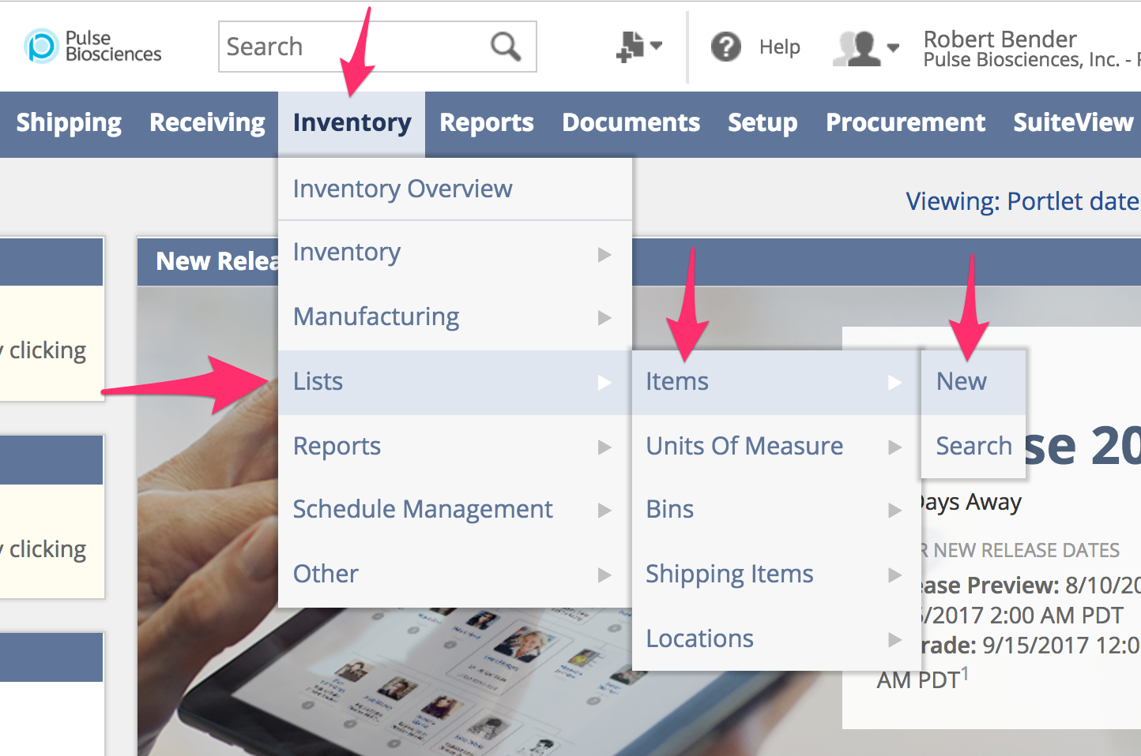

2. We’re creating a **New Lot Numbered Assembly** Item using SA2000 as an example:

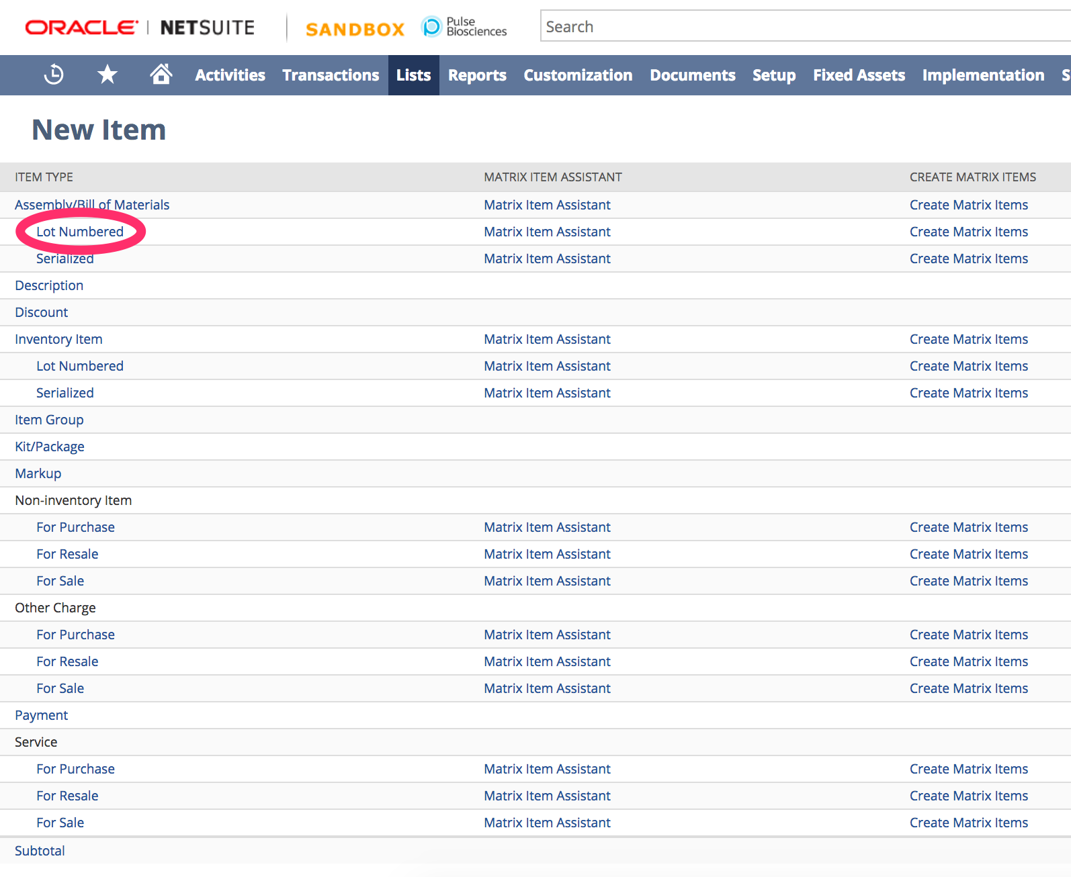

Alternatively, you may select Serialized to create a Serialized Assembly Item, but for this example we will be creating a Lot Controlled Assembly Item.

3. Assembly Item example with SA2000 (Required Fields shown with a Red Arrow):

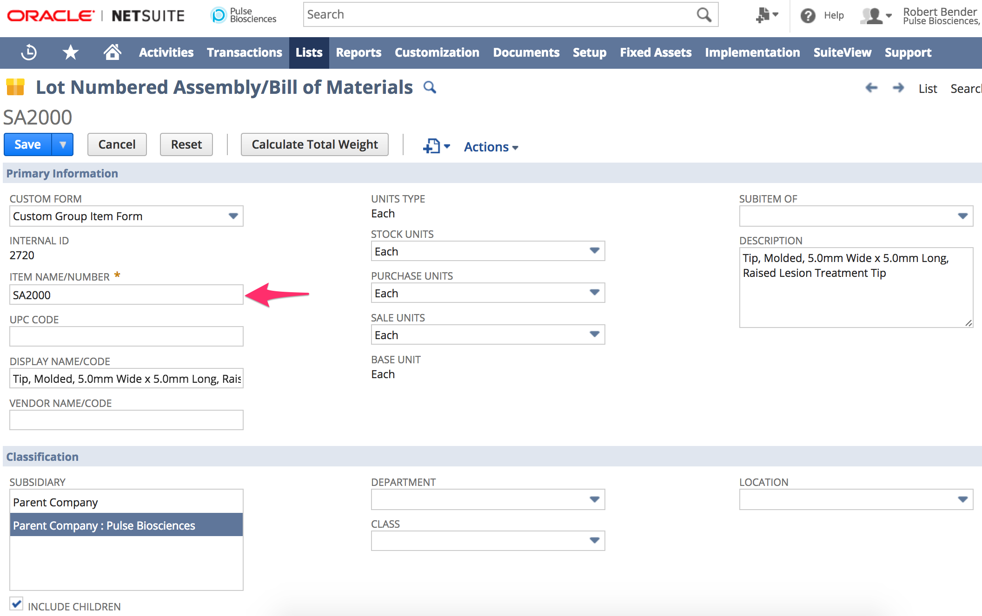

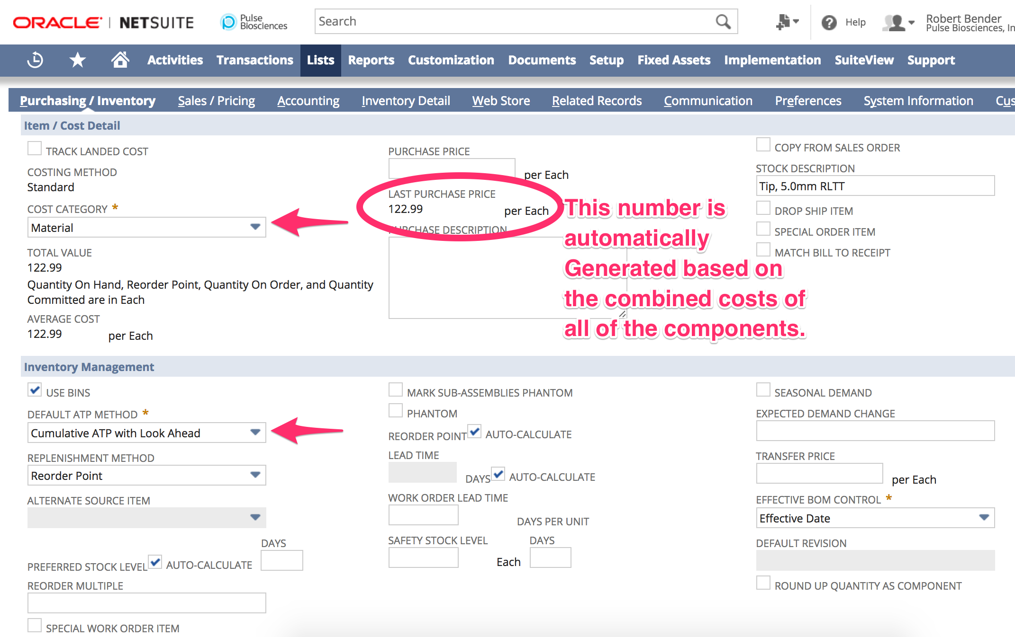

At the bottom click the **Components** tab to add all of the inventory items that make up the Assembly item we are creating.

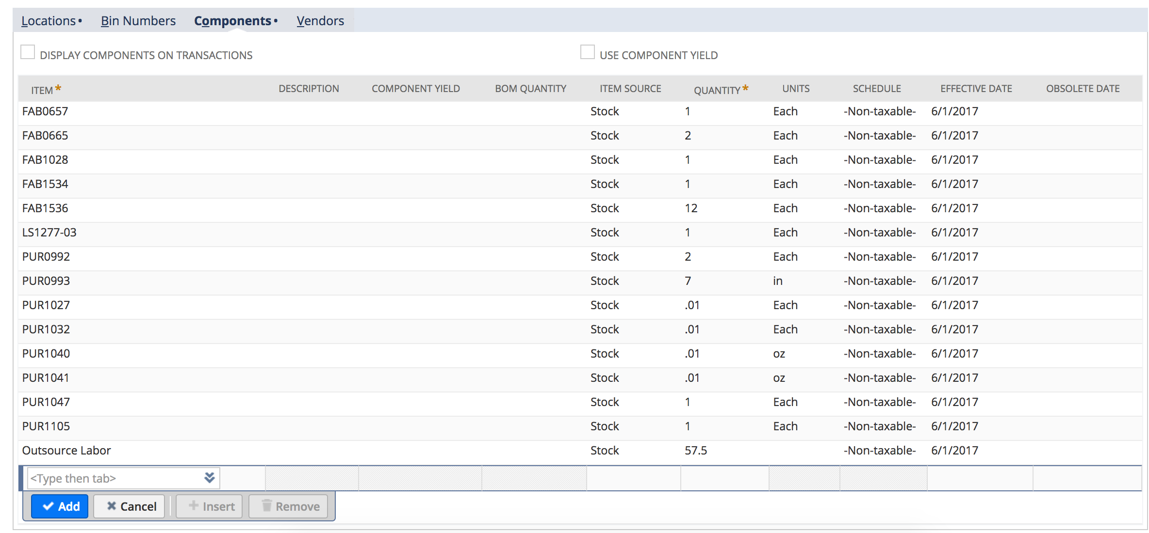

Finally, set the preferred **Location** of this item, once you save your new item the on hand quantity and average costs will be shown here.

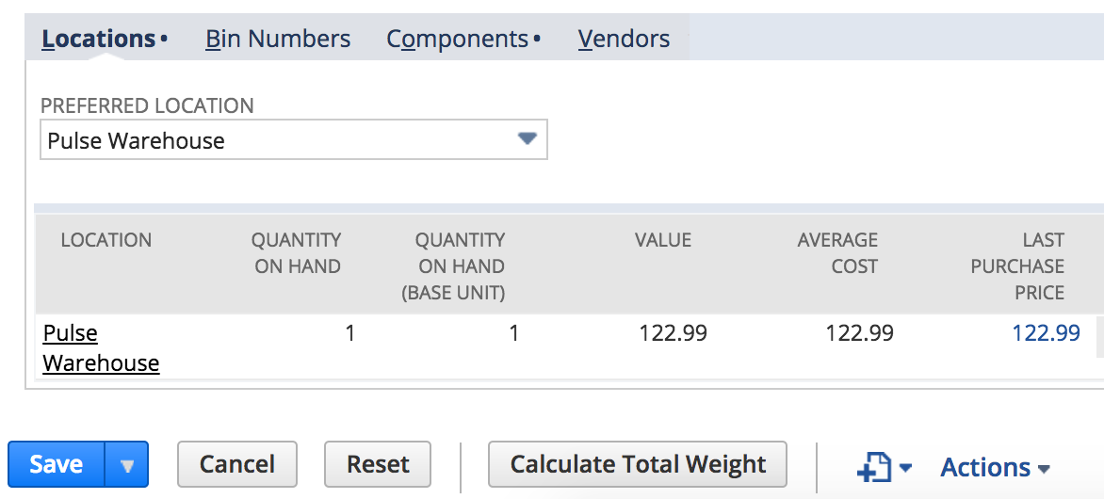

**B. Controller - New Standard Cost Version**

As costs of inventory items change over time we can create different Standard Cost Versions (typically by quarter) to segment and track our costs.

1. Financial > Cost Accounting > Standard Cost Versions > New

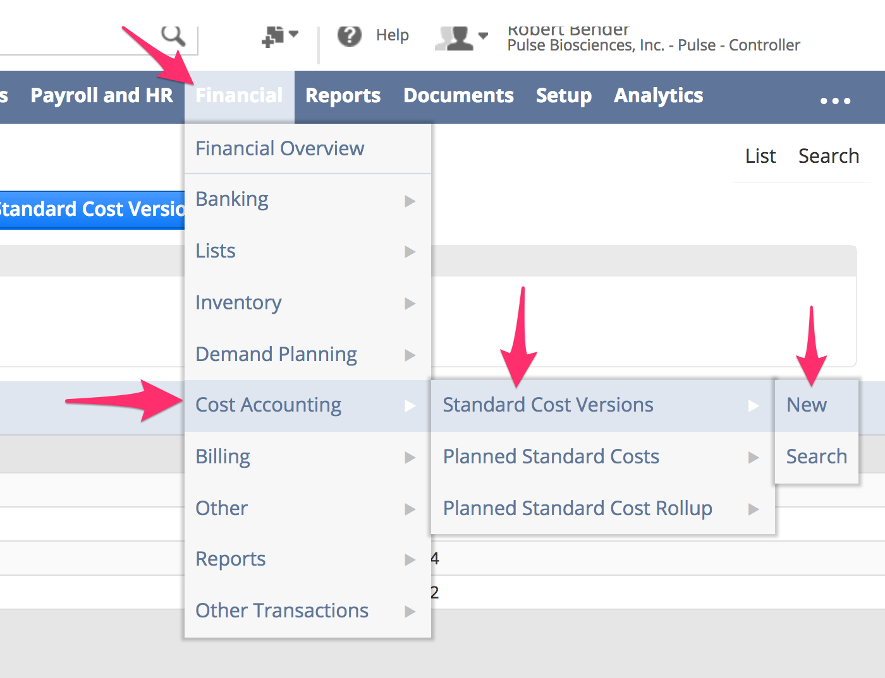

A standard cost version is a label to identify a time period or other identifying characteristic that you use to identify costs for items. Having various cost version records allow you to record the cost you expect to incur for an item at a particular time.

Knowing the expense you expect to pay for an item helps you to track cost variations by giving you a point of comparison after you have an actual cost or bill for an item. For example, if you record that you expect to pay $5 each for Item A this month, but later you get a vendor bill for Item A at $8 each, you can know that your costs for that month are higher than you anticipated.

Creating standard cost version records helps you track these variances. Each cost version stores a standard cost to be used on different occasions. You can use multiple cost versions per item to track expected costs over time.

For example, if the cost of an item is expected to change each quarter, you can create a cost version for each quarter:

Q3 2011

Q4 2011

Q1 2012

Q2 2012

When you have a cost version for each quarter, you can track the specific expected cost for each quarter.

Cost versions are not limited to being based on quarters or time periods, they can identify any specifying information that you choose.

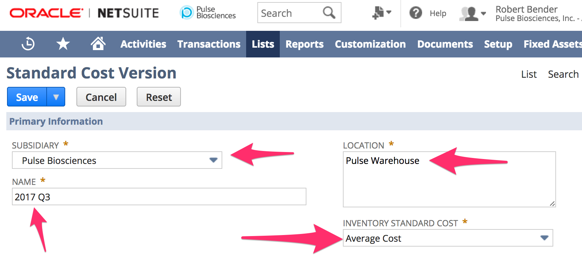

In the example above we set the Inventory Standard Cost to Average Cost so that it will display the average cost of the assembly item as a an average cost of the combined components.

**C.1. Controller -  Item Costing**

1. New Planned Standard Item Costs

Financial > Cost Accounting > Planned Standard Costs

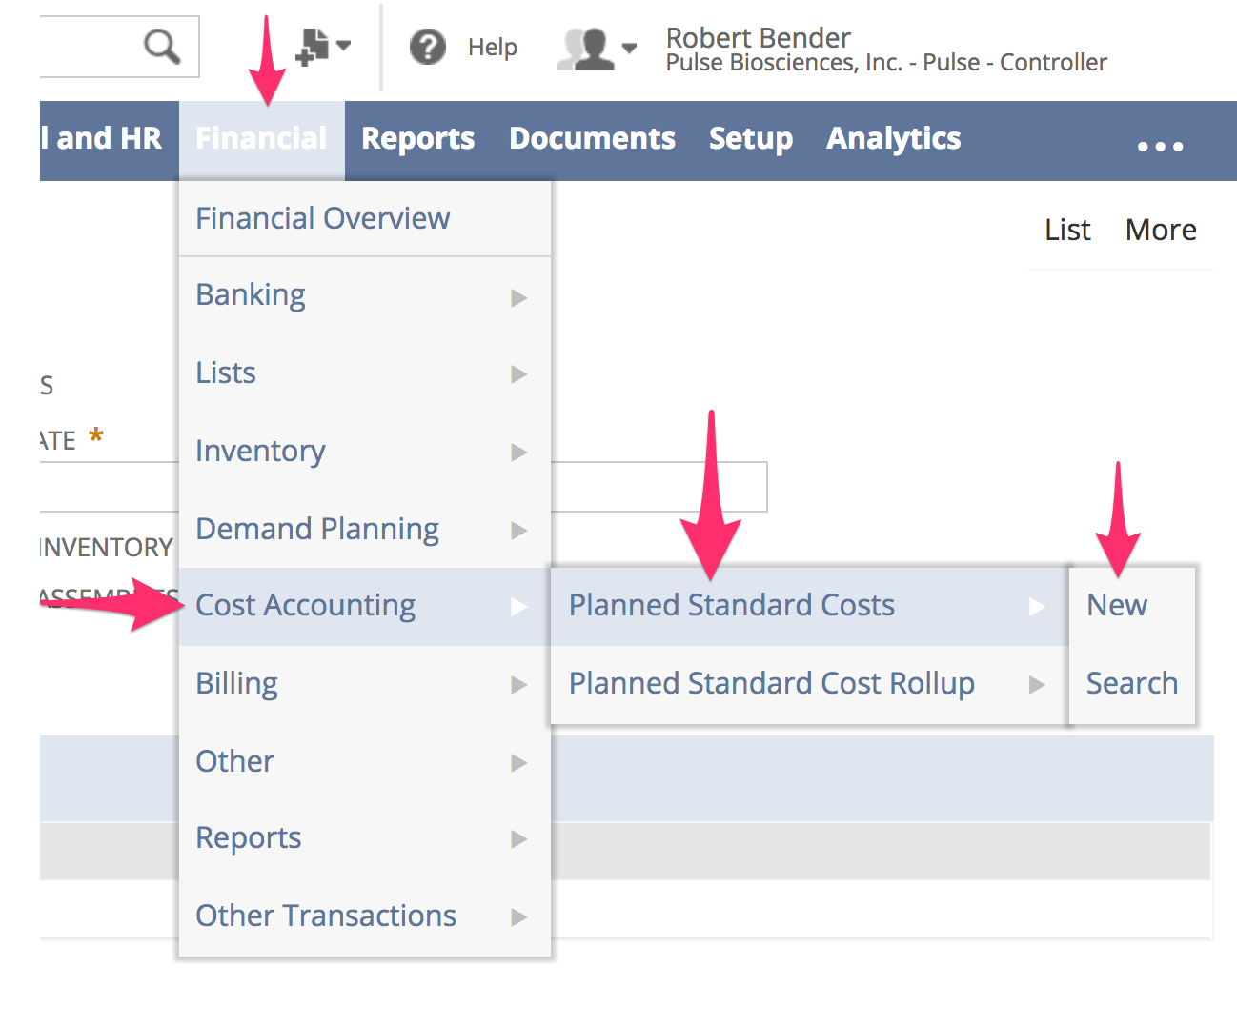

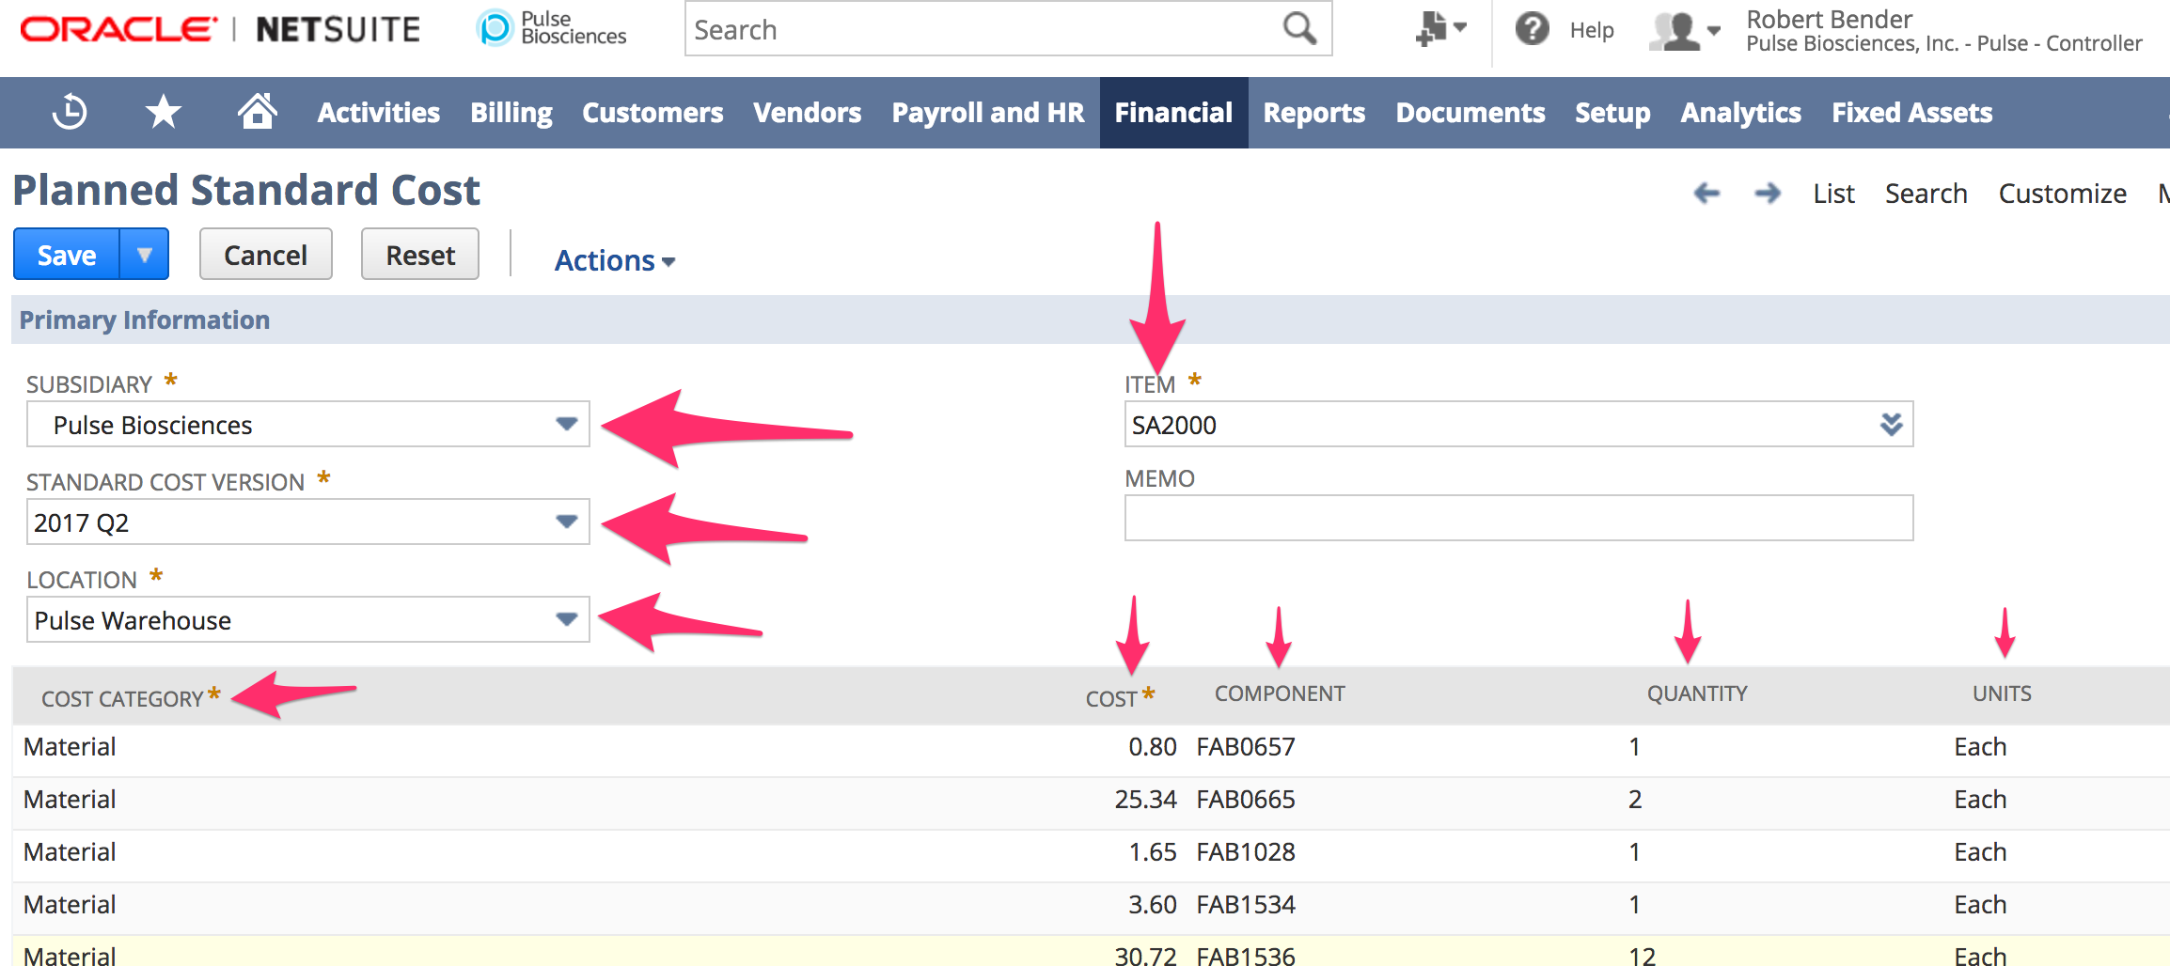

Determining Item Cost

The cost of an item is determined at the time you receive it into inventory, either through a purchase or an inventory adjustment. Item cost is determined by the price of the item that shows on the purchase order.

When you determine the cost of an item, you might need to account for costs associated with buying the same items at different purchase prices over time.

For example, sometimes you pay your vendor $10 for each calculator. Other times, the price is $15 for each calculator. You can choose a costing method to determine how NetSuite handles these variances.

The exact cost assigned to an item depends on the costing method you choose. For more information, read Setting a Default Inventory Costing Method.

**Entering Planned Standard Cost Records**

Using Standard Costing, you can compare the expected cost for an item with the actual cost incurred. To make this comparison, you need to define the expected cost for each cost version. This information is defined on planned standard cost records.

Planned standard cost records are a tool to map out your plan for expected expenses. Planned standard cost records are a draft to track the standard, or expected, cost of items you anticipate using in the future. The standard cost is a fixed amount that you plan for as an expense.

You can create and store any number of planned standard cost records to anticipate a variety of potential costing scenarios.

For example, you know a specific cost you expect to incur for an item on a particular date. You can enter a planned standard cost record to show the cost you expect for an item on specific future dates. You migh expect an item to cost $10 during January, but anticipate a rise in the cost to $20 during February. Your planned standard cost record plans for these cost fluctuations.

The planned standard cost record stores the fixed standard cost amount for an item, and each cost can be identified by a Cost Version and a Cost Category, as shown below:

Cost Version

Item Name

Cost Category

Standard Cost

Q3 2011

Item AB1001

Material: Wood

$10

Q4 2011

Item AB1001

Material: Wood

$20

Q1 2012

Item AB1001

Material: Wood

$30

Q2 2012

Item AB1001

Material: Wood

$50

You can see by the above planned standard cost record that prices for Item AB1001 are expected to rise over time. In Q3 the anticipated cost is $10, for Q4 it is $20 and further upwards over time.

When you assign a cost category, the cost is itemized in the specified category during the time that this cost version is used in production. As shown below, the parts of the assembly process for Assembly Widget A are categorized by materials and labor.

Planned Standard Cost Record: Assembly Widget A--Q3 2011

Cost Category

Cost

Item

Quantity

Material: Metal

$90

Metal Component 1

3

Material: Wood

$50

Wooden Component 2

2

Labor: Assembly

$40

Widget Assembly

1

Labor: Painting

$30

Widget Painting

1

Included is the quantity of each component which records the amount you expect to use in a build. This information is used to calculate variances by comparing expected usage to actual usage.

**Creating New Planned Standard Cost Records**

A new planned standard cost record can be created either manually or automatically.

**• Automatic** standard cost records are created for assembly items when you run a cost rollup.

◦ Automatic standard cost records show costing data based on NetSuite calculations of component item costs.

◦ When an automatic standard cost record is generated, the new calculated costs will overwrite the previous manual data if a standard cost record has previously been entered manually for the item.

• For details, read [Standard Cost Rollup](https://system.na2.netsuite.com/app/help/helpcenter.nl?fid=section_N2204939.html).

**• Manual** standard cost records are created when you complete the steps below to enter costing data for an item by hand.

**To manually create a new planned standard cost record:**

1. Go to Financial > Cost Accounting > Planned Standard Costs > New.

2. Choose a **Standard Cost Version**.

3. Select a location. The location you choose determines the location where you can push this version to production and use it for standard costing calculations.

4. Select an item.

5. Select a **Cost Category**. This category defines how cost variances will be tracked.

6. In the **Cost** field, enter the standard cost for the item to be associated with the selected category. This is the fixed cost you expect to pay.

◦ If the item you selected is not an assembly item, this is the cost of the item selected in the header.

◦ If the item you selected is an assembly item, this is the cost of the component on this line.

7. If the item you selected is an assembly item, complete these fields:

a. Select a component.

b. Enter a quantity. This is the number of this component you expect to use in a build.

c. Enter a unit of measure.

8. Click **Add**.  
  
For assembly items, you can associate multiple cost categories to track costs. If you select only one category, the entire standard cost of the item is tracked in that category.

9. Repeat these steps for each cost category you need to track for this assembly item.

10. Click **Save**.

**Best Practice: Creating planned cost records using import and Cost Rollup**

You can use import functions and the Standard Cost Rollup form to create planned cost records for the inventory items. When you process the rollup, it creates the revaluation and all the planned cost records for the inventory items.

**Use the following steps to create new records:**

1. Import the cost to the **standard cost** field on the item record using CSV Import or Web Services. Read [CSV Imports Overview](https://system.na2.netsuite.com/app/help/helpcenter.nl?fid=chapter_N342646.html).

2. Create a cost version with **Item Default** selected as the inventory cost. Read [Defining Cost Versions](https://system.na2.netsuite.com/app/help/helpcenter.nl?fid=section_N2202327.html).

3. Run the cost rollup. Read [Standard Cost Rollup](https://system.na2.netsuite.com/app/help/helpcenter.nl?fid=section_N2204939.html).  
When you run the rollup, NetSuite creates all the planned standard costs for the inventory items. These are based on the item record value when the **Update Inventory Cost** box is checked on the item record.

4. Run a revaluation. Read [Revaluing Standard Cost Inventory](https://system.na2.netsuite.com/app/help/helpcenter.nl?fid=section_N2205401.html).

**C.2. Controller -  Item RollUp**

Financial > Cost Accounting > Planned Standard Cost Rollup

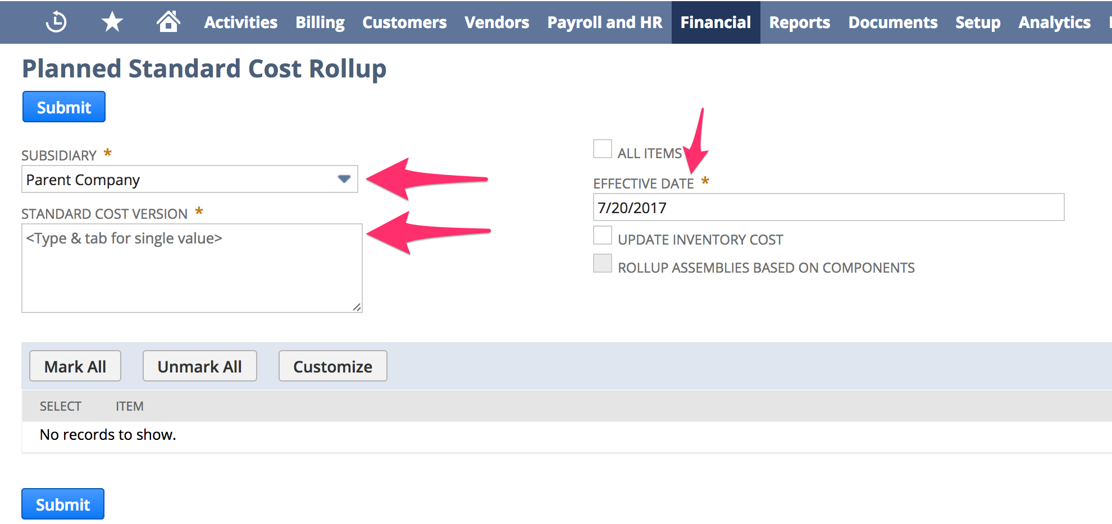

**Standard Cost Rollup**

The standard cost rollup helps maintain accurate costing data for assembly items by calculating the standard cost of assemblies. The cost of an assembly is determined based on current costs of member components.

The cost rollup process calculates the fixed cost based on data entered on the planned standard cost record. This allows the most accurate cost of each assembly component to be used in costing calculations.

For example, you want to know the cost of Assembly Item D. Assembly Item D is comprised of one each of Item A, Item B and Item C. The cost of each component is multiplied by the number used in the assembly, and the sum is totaled to find the current cost of the assembly.

When a cost rollup is performed, NetSuite examines planned standard cost records to find the following:

• Item A = $5

• Item B = $6

• Item C = $7

Using this data, NetSuite calculates the cost of Item D as (5 + 6 + 7) = $18. After the cost is calculated, this information is stored. This enables you to track your expected cost of $18 for Assembly Item D.

In addition, cost calculations are performed for all parent component items. If an assembly has a component that is itself an assembly item, the same calculation is performed for the sub-assembly members as well. The cost calculations are performed all the way down to the lowest sub-assembly level and rolled up to find the cost of the parent assembly item.

• A cost rollup is performed on an item *only if that assembly has a cost category selected* on the item record. Then, the calculated costs are broken out by components and cost categories.

• The standard cost of all assemblies are calculated regardless of whether its components items use actual, average, or standard costing.

**To run a cost rollup:**

1. Go to Financial > Cost Accounting > Planned Standard Cost Rollup.

2. Select one or more **Standard Cost Versions**. Click the icon to open a multi-select popup window.  
A list of items corresponding to the cost versions shows.

3. In the **Effective Date** field, enter the date you want the new standard cost to take effect.  This defaults to the current date.

4. Check the **Update Inventory Cost** box to set the standard cost of all planned standard cost records of inventory items.  
When this box is checked, the planned standard cost records of inventory items are created or updated based on the inventory costing method defined on the cost version. When the default item record selection is used on the cost version, the cost rollup process reflects the cost in the **Standard Cost** field on the item record for each item selected. Also, the planned standard cost of inventory items is automatically generated as part of the rollup process.  
The next time you open this form, NetSuite checks or clears the box based on the previous use.

5. The **Rollup Assemblies Based on Components** preference enables you to select only the component and NetSuite creates inventory revaluation entries for all the higher-level assemblies. For example, you can introduce a new component for several existing assemblies, as shown:

◦ Assembly A, Subassembly B, Component C (new)  
Check the Rollup Assemblies Based on Components box and select component C on the form. When you submit the form, NetSuite finds all the associated assemblies within the entire bill of materials (BOM) tree and creates inventory revaluation transactions for the component and for the assemblies (A,B,C).

6. Check the **Select** box next to an item to include it in the cost rollup calculations. Clear the box next to an item to exclude it from calculations.  
Check the **All Items** box to perform calculations for all items.

7. Click **Submit** to perform the calculations.

When you submit the form, the cost rollup calculations are performed and the planned standard cost record for all items and sub-items are updated or created. The list of these newly calculated planned standard cost records is displayed.

Click the View or Edit link next to a planned standard cost records for details on that record.

**D. Controller - Fixed Assets module**

Fixed Assets > Fixed Assets Overview

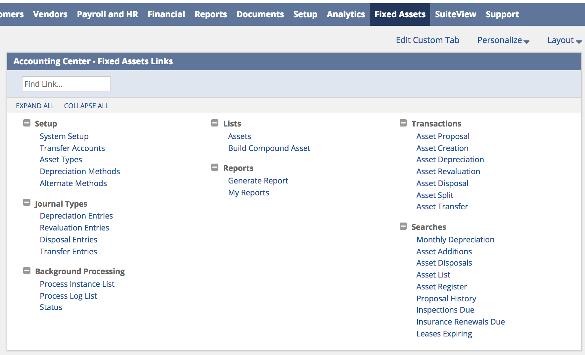

The NetSuite Fixed Assets Management SuiteApp helps you manage fixed assets acquisition, depreciation, revaluation, and retirement, as well as asset maintenance schedules and insurance.

For more detail see this PDF: <https://system.na2.netsuite.com/help/helpcenter/en_US/PDF/fixedassetsmanagement.pdf>